Science |  |  |  |  |  | History – The Roman Empire |  |  |  |  |  |  |  | Geography
 |  |  |  |  |  | Key Theme: Legacy |  |  |  |  |  |  |  | (History Theme)
Working scientifically |  |  | Knowledge |  |  | Concept |  |  | Knowledge |  |  |  |  | Concepts |  | Knowledge
Taps: Investigating ice cubes  Plan: Suggesting the appropriate enquiry to make.  Recognising when a test is fair and suggesting ways to keep it fair.  Do: Present findings using scientific vocabulary  Record: Their findings in writing  Evaluate: Explain their findings in writing |  |  | States of matter  What are the different states of materials? (gas, liquid and solids) Can I group materials according to their states?  How do some materials change state when they are heated or cooled?  At what temperature do these changes happen (in degree Celsius)?  What is evaporation and condensation and how do these influence the water cycle?  What happens to water as it is heated and cooled to various temperatures? |  |  | Significant events and people |  |  | Who were the Romans?  Who were famous Romans and what do we know about them?  Who was Boudica and why did she become so famous? |  |  |  |  | Place
 |  |  |  |  |  | Context and chronology |  |  | When did the Romans invade Britain (timeline including Stone Age/ Iron Age/ Current Day and other known periods |  |  |  |  | Location |  | What are the names of the main countries in Europe?  What are the major cities of these countries?  Can I identify these countries and cities on a map?  (Link to Roman Empire)
 |  |  |  |  |  | Similarity and difference |  |  | How did daily life change under the Romans?  How did Roman times compare to other known time periods (stone Age/Iron Age) |  |  |  |  | Geographical skills and field work |  | Use books, pictures, internet, atlases, satellite images and aerial photographs as sources of information  Investigate places at more than one scale  Use letter/no coordinates to locate features on a map confidently  Locate places on a large scale map/globe
 |  |  |  |  |  | Continuity and Change |  |  | What was Britain like at the time the Romans invaded and how did it change?
Vocabulary |  |  | See vocabulary list |  |  | Cause and consequence |  |  | Why did they leave?  How has Roman Civilisation influenced Modern Day? |  |  |  |  | Environment
 |  |  |  |  |  | Historical enquiry |  |  | Reliability of sources / Seeking further evidence  Roman History visitor to school with artefacts |  |  |  |  | Physical and human processes |  | What are the key physical and human characteristics of these countries?
 |  |  |  |  |  | Vocabulary |  |  | See vocabulary list |  |  |  |  | Vocabulary |  | See vocabulary list
Art and Design |  |  |  |  |  |  | 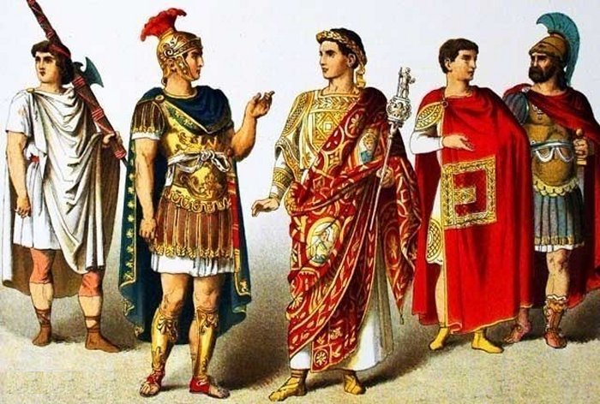  Year 4  Theme 1  What did the Romans do for us? |  |  |  |  |  | Music (Charanga)
Artist/s |  | Antoni Gaudi (1852-1926) – mosaics |  |  |  |  |  |  |  |  |  |  | Charanga |  |  | Theme 1
Area of Study/activities |  | Visual: Roman mosaics were a common feature of buildings across the empire. Not only are mosaics works of art but they are also a record of everyday items; clothes, food, tools, weapons, etc. Study examples and compare to the work of Gaudi.  Technical: In sketch books design their own mosaic, including colours, textures etc. and then produce it using clay tiles.  Personal and conceptual: Compare their finished art to their sketches. What worked well? What could have been improved? |  |  |  |  |  |  |  |  |  |  | Title |  |  | Flute Step 1/2
 |  |  |  |  |  |  |  |  |  |  |  |  | Style |  |  | Instrument tuition from Services for Education  (See Charanga for lesson planning)
Vocabulary |  | Mosaic, texture, clay, Gaudi, mouldable
Art form |  | 3D Mosaics |  |  |  |  |  |  |  |  |  |  | Performance |  |  | Carol service/ Class assembly
Design and Technology |  |  |  | Religious Education |  |  |  | MFL - French |  | PSHEC & Relationships |  |  |  |  | Computing
Area | Structures |  |  | Disposition | Content |  |  | Gramacri French  Unit 6/7  All about me  French Phonics  (See Gramacri planning for further information) |  | Concepts |  | Knowledge |  |  | Skills |  | Declarative Knowledge
Brief | Design and make a Roman aqueduct |  |  | Being attentive to the sacred as well as the precious  Being courageous and confident  Being hopeful and visionary | The story of Elijah  Silent attentiveness  Basahki  The story of Gideon  The work of the street pastors  Martin Luther King  Altruism and practical action  (See Birmingham Agreed Syllabus for lesson planning) |  |  |  |  | Power  Relationships Change and resilience |  | To know the difference between a democracy and a dictatorship (BV)  To know what bullying is and how to respond.  They can describe the nature and consequence of bullying and can express ways of responding to it.  To know what a friend is and does and how to cope with some friendship problems. |  |  | Computer Science: Computer Systems and Networks  The Internet   |  | I understand how networks connect and communicate with each other and that together, the global interconnection of networks make up the Internet.  I know that the World Wide Web (WWW) is a collection of websites and web pages, and that the Internet enables us to view these.  I understand that WWW content can be created by anyone and shared with everyone.  I understand the limitations, reliability and benefit of the World Wide Web and its content.
Research | Research Roman aqueducts. What were they for? What were they made from?
Design | Design their own version of an aqueduct.  - Choose the materials/tools they will use, based on their suitability for the task.  - Draw a fully labelled diagram of their product, including some measurements.  - Indicate where/how materials will be joined in order to create a stable structure.  - Work with a partner to share and modify designs
Create | Make the aqueduct, testing and modifying it to ensure it is fit for purpose. Ensure their product meets design criteria. |  |  |  |  |  |  |  |  | Vocabulary |  | See vocabulary list
Evaluate | Discuss whether the product meets the requirements of the brief/the needs of the user – is it fit for purpose?  Take part in peer evaluation, giving and receiving feedback from fellow pupils. |  |  |  |  |  |  |  |  |  |  |  |  |  | Vocab  Network, data, World Wide Web, Internet, web page, website, content, media, copywrite |  | Procedural Knowledge  I can describe what the Internet is, and how devices physically connect.  I can explain what the World Wide Web is, and the difference between it and the Internet.  I can explain the different types of content that can be created for the WWW and evaluate its reliability, the usefulness of content created, and the consequences of unreliable content
Vocabulary | See vocabulary list
English – Reading and Writing |  |  |  |  |  |  |  |  |  |  | Maths
 |  |  |  |  |  |  |  |  |  |  | Number: Place value  Represent numbers to 1,000  Partition numbers to 1,000  Number line to 1,000  Thousands  Represent numbers to 10,000  Partition numbers to 10,000  Flexible partitioning of numbers to 10,000  Find 1, 10, 100, 1,000 more or less  Number line to 10,000  Estimate on a number line to 10,000  Compare numbers to 10,000  Order numbers to 10,000  Roman numerals  Round to the nearest 10  Round to the nearest 100  Round to the nearest 1,000  Round to the nearest 10, 100 or 1,000  Number: Addition and Subtraction  Add and subtract 1s, 10s, 100s and 1,000s  Add up to two 4-digit numbers – no exchange  Add two 4-digit numbers – one exchange  Add two 4-digit numbers – more than one exchange  Subtract two 4-digit numbers – no exchange  Subtract two 4-digit numbers – one exchange  Subtract two 4-digit numbers – more than one exchange  Efficient subtraction  Estimate answers  Checking strategies  Measurement: Area  What is area?  Count squares  Make shapes  Compare areas
  Theme 1
  What did the Romans Do for Us?
  Key Text | Linked Texts | Writing Outcomes | Speaking and listening | Genre | Purpose/Audience
  NA | NA | Baseline narrative | Review writing targets | Narrative | Assessment  CT
  Empire’s End – A Roman Story  Leila Rasheed | Journey  Aaron Becker | Write a journey tale that includes a description of setting | Tableau/Role play exploring different settings | Fiction | Writing to Entertain  Mrs Beesley
  The Strong and the Crazy Emperors of the Roman Empire  Baby Professor |  | Create a fact file for their own Roman Emperor. | Hot seating Roman Emperors to understand character | Faction | Writing to inform  Dame Mary Beard
  So You Think You’ve Got it Bad – Ancient Rome  Chae Strathie | We Are the Romans  David Long  Grammarsaurus WAGOLL/WABOLL | Write a short balanced argument “Were the Romans Good or Bad for Britain?” | Debate club in class | Non-Fiction | Writing to Discuss  Bettany Hughes
  Grammar | Grammarsaurus: Place Value of Grammar  Write using expanded noun phrases  Write multi-clause complex sentences using a variety of coordinating conjunctions  Write multi-clause complex sentences using subordinating conjunctions: ISAWAWUBUB  Write using pronouns and nouns within and across sentences
  Punctuation | Full stop, commas (in a list),

